BFS ALGORITHM

AIM: To implement a python program for BFS.

OBJECTIVES:
- To traverse all nodes of a graph level by level.
- To visit each node only once.
- To find the shortest path in an unweighted graph.

ALGORITHM:
- Create a graph using a dictionary.
- Create an empty list for visited nodes.
- Create a queue and insert the starting node.
- Remove the first node from the queue.
- If it is not visited, print it.
- Add all its unvisited neighbors to the queue.
- Repeat until the queue becomes empty.

SYSTEM-ARCHITECTURE:
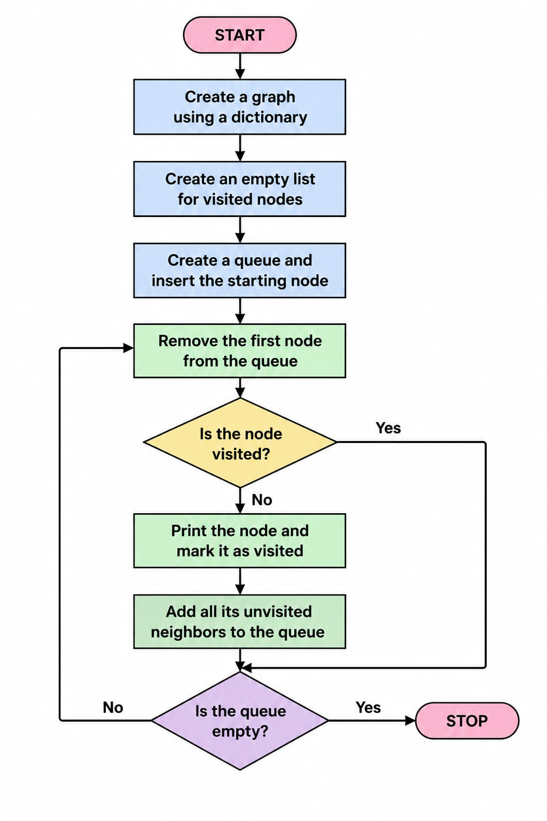

PROGRAM:
graph={'A':['B','C'],'B':['D'],'C':['E'],'D':[],'E':[]}
visited=[]
queue=['A']
while queue:
node=queue.pop(0)
if node not in visited:
print(node,end=" ")
visited.append(node)
queue.extend(graph[node])

OUTPUT:
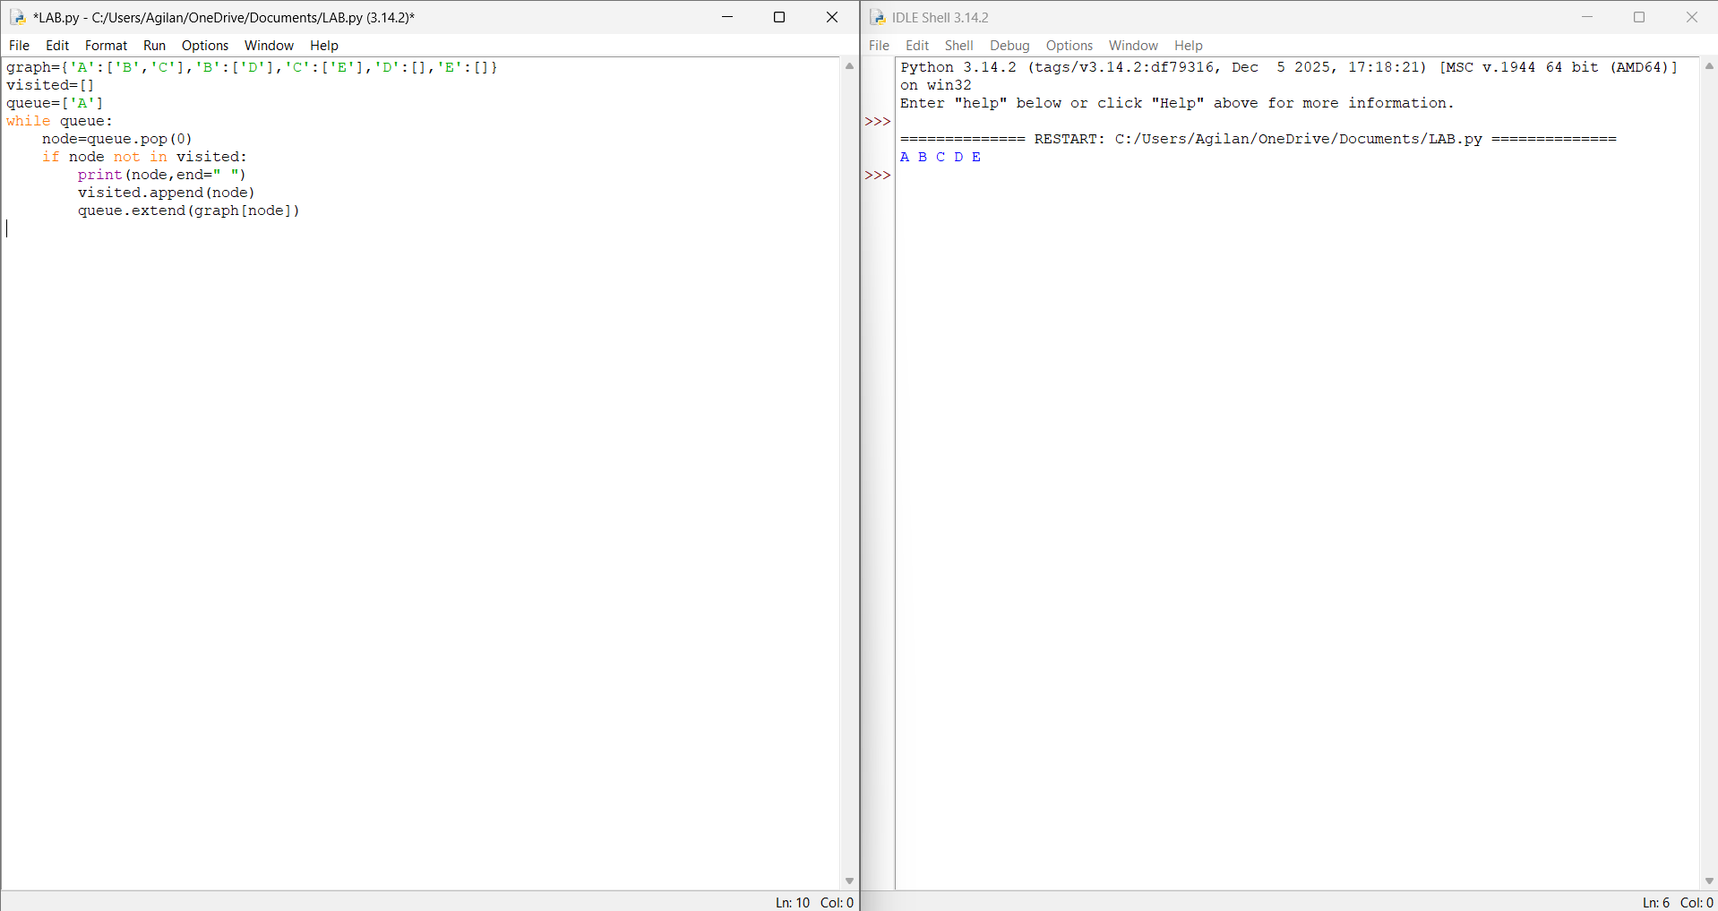

RESULT:
Thus the BFS is implemented successfully using python language.

